Claude de Calan
When Vincent was playing with Feynman graphs
Abstract. This communication presents some features of the work made by Vincent Rivasseau in perturbative quantum field theory. Without giving technical details, we recall the main ideas leading to prove the local existence of the Borel transformed amplitudes for the φ⁴ model in 4 dimensions. Comments are also given concerning the same model in 3 dimensions.

Vincent Rivasseau will become very old in a few days, reaching the sixties. I take this opportunity for talking a little about the way Vincent worked, since I had the pleasure to work with him, many years ago. As you know, Vincent started in theoretical physics with a strong background in mathematics, being “agrégé de mathématiques”. Rigor and logics had no secret for him. Nevertheless I think that the main tool he used has always been intuition. Before reasoning, Vincent is guessing intuitively and this quality is the source for many of the successes he gained in his life. I will not give an extensive list of these achievements : you can find a more complete one in the talk of Jacques Magnen.
Now, as you may guess, from original intuition up to firm results, there is often a rather long road, a road which usually implies a lot of trials and errors. I would like to illustrate this by recalling some features of the road we covered together in the study of the perturbative series for the φ⁴ model in 4 dimensions. During the seventies, much attention has been paid to the Borel transformation. Let
A = A₀ + g A₁ + g² A₂ + ... + g^{n} A_{n +} …
be the perturbative expansion of some amplitude. Its Borel transform is :
B = A₀ + t A₁ + ½ t² A₂ + ... + 1/n! t^{n} A_{n +} …
If the A_{n} are not too large, this new series may converge for t small enough, leading to the local existence of the Borel transform. Of course this is not enough for Borel summability. For the inverse Borel transformation to be possible, the analyticity of B on a neighborhood of the real positive axis, and a behavior at large t not too drastic, are required.
For dimension 2, Borel summability of the φ⁴ model has been proved in 1975 by Eckmann, Magnen and Sénéor [1], and for dimension 3 in 1977 by Magnen and Sénéor [2]. Local existence of the Borel transform for any dimension ν (interpolated to complex values), provided Re ν is strictly less than 4, has been proved in 1980 by Rivasseau and Speer [3]. Actually, A_{n} is given by 1/n! times the sum of the amplitudes A_{G} for all the Feynman graphs G with n vertices. The number of such graphs in the φ⁴ model is bounded by K^{n}(n!)² where K is a constant. Proving a bound on each A_{G} by C^{n} where C is also a constant leads to the local existence of the Borel transform.
Now, in the case of dimension 4, the situation seemed to be hopeless. If we consider for example the graph of fig.1
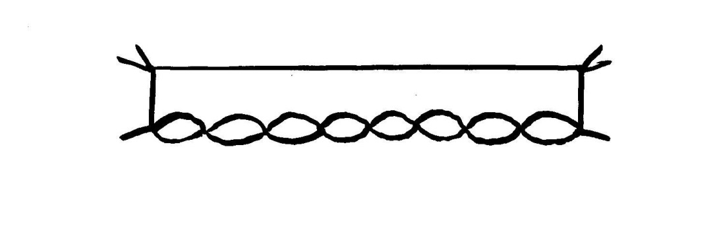

Fig. 1
we find that A_{G} is of the order of C^{n} n! (instead of C^{n} for lower dimensions). This happens because each 4 legs-subgraph (which we call a quadruped) must now be renormalized.
At this point enters the first intuition of Vincent : OK, there are on the whole (n!)² graphs and some of them produce an additional n! factor. But how many ? The following conjecture might be not so crazy : at a given order n, when the number of renormalizations to be performed increases, the number of concerned graphs decreases. Here was the good track.
But then begins the long way I was talking before. We have to work hard to define what the relevant number of renormalizations is. As we know since Bogoliubov, Zimmermann and others, renormalization can be realized by applying Taylor operations on the Feynman integrand. The Taylor operators act on the various subgraphs, and only sets of non overlapping subgraphs have to be considered simultaneously. Such sets are called “forests”. We define, for a given graph, the number f as the maximum value of f(F ) over all possible forests F.
with f(F ) = q(F ) + 2b(F )
where q(F ) is the number of quadrupeds in F and b(F ) the number of bipeds in F.
We are now left with two steps :
Step 1 : bounding the value of the renormalized Feynman integral. We use the α-parametric representation, the splitting of the integration domain into Hepp sectors (all orderings of the α parameters) and a subtle classification of forests in each sector. Finally we obtain
Theorem I : |A_{G}| ≤ K₁^{n} f! where K₁ is a constant
Step 2 : counting the number of graphs corresponding to a given value of f. This requires a hard combinatoric analysis. But the convenient definition of f leads to a marvelous bound (actually, a carefully prepared miracle) :
Theorem II : N(f) ≤ K₂ 1/f! (n!)²
where N(f) is the number of graphs with n vertices and a given f.
Setting up theorems I and II gives the final result:
A_{n} ≤ K^{n} n! which implies le local existence of the Borel transform [4].
On the other hand, there are arguments for suspecting that renormalization generates singularities (“renormalons”) on the real positive axis in the t complex plane, which would prevent Borel summability : at the present time, the existence of the φ⁴ model in 4 dimensions is just not granted !
Before concluding, I would like to ask a very naïve question : after all, does the original perturbative series really diverge ? For the φ⁴ model in 2 dimensions the divergence (vanishing of the radius of convergence) has been proved in 1965 by Jaffe [5]. In 3 dimensions, the needed mass renormalization introduces subtractions. The various contributions have positive and negative signs, making difficult the proof of lower bounds. We reexamined this problem in 1982 [6]. The intuition of Vincent said that since the only divergent subgraphs are bipeds, they enter in a topologically simple way. By a recursive reduction process of the graphs, we succeeded in proving lower bounds and finally the divergence of the perturvative expansion. Of course this result was an anecdotic one : purely negative and rather expected. But the funny fact is that we obtained it very easily : after two or three weeks. Sometimes the path between intuition and rigorous proofs is not too long !
When the path is longer, like in our study in 4 dimensions, the method of trials and errors takes place. The intuition of Vincent, from time to time, generates errors. (By the way, I generated myself many errors as well…) But I want to insist on the fact that producing wrong ideas is not a serious problem, just because we do not work alone. Colleagues will check and correct when necessary. The problem is not producing wrong ideas besides the good ones. The only redhibitory defect is producing no idea at all. And Vincent produced many. Though Vincent is now becoming so old, I am sure he will produce again a lot of new and beautiful ideas in the future.

References
[1] Eckmann J.-P., Magnen J., Sénéor R. : Commun. Math. Phys. 39, 251 (1975)
[2] Magnen J., Sénéor R. : Commun. Math. Phys. 56, 237 (1977)
[3] Rivasseau V., Speer E. : Commun. Math. Phys. 72, 293 (1980)
[4] de Calan C., Rivasseau V. : Commun. Math. Phys. 82, 69 (1981)
[5] Jaffe A. : Commun. Math. Phys. 1, 127 (1965)
[6] de Calan C., Rivasseau V. : Commun. Math. Phys. 83, 77 (1982)

